**Descriptives**

|  |  |  |  |  |  |
| --- | --- | --- | --- | --- | --- |
| **Descriptive Statistics** | | | | | |
|  | N | Minimum | Maximum | Mean | Std. Deviation |
| DER | 32 | 1.23 | 3.30 | 2.1105 | .59652 |
| ROA | 32 | .08 | .76 | .2624 | .14836 |
| Harga_Saham | 32 | 3907.30 | 10666.73 | 7534.4909 | 1923.16165 |
| Valid N (listwise) | 32 |  |  |  |  |

**Pengaruh *Debt to Equity Ratio* Terhadap Harga Saham**

|  |  |  |  |  |
| --- | --- | --- | --- | --- |
| **Model Summary** | | | | |
| Model | R | R Square | Adjusted R Square | Std. Error of the Estimate |
| 1 | .303a | .092 | .062 | .27187 |
| a. Predictors: (Constant), DER | | | | |

|  |  |  |  |  |  |  |
| --- | --- | --- | --- | --- | --- | --- |
| **ANOVAa** | | | | | | |
| Model | | Sum of Squares | df | Mean Square | F | Sig. |
| 1 | Regression | .224 | 1 | .224 | 3.032 | .092b |
| Residual | 2.217 | 30 | .074 |  |  |
| Total | 2.442 | 31 |  |  |  |
| a. Dependent Variable: HR1 | | | | | | |
| b. Predictors: (Constant), DER | | | | | | |

|  |  |  |  |  |  |  |
| --- | --- | --- | --- | --- | --- | --- |
| **Coefficientsa** | | | | | | |
| Model | | Unstandardized Coefficients | | Standardized Coefficients | t | Sig. |
| B | Std. Error | Beta |
| 1 | (Constant) | 8.591 | .179 |  | 47.905 | .000 |
| DER | .143 | .082 | .303 | **1.741** | .002 |
| a. Dependent Variable: HR1 | | | | | | |

**Pengaruh Return on Assets Terhadap Harga Saham**

|  |  |  |  |  |
| --- | --- | --- | --- | --- |
| **Model Summary** | | | | |
| Model | R | R Square | Adjusted R Square | Std. Error of the Estimate |
| 1 | .177a | .031 | -.001 | .28078 |
| a. Predictors: (Constant), ROA | | | | |

|  |  |  |  |  |  |  |
| --- | --- | --- | --- | --- | --- | --- |
| **ANOVAa** | | | | | | |
| Model | | Sum of Squares | df | Mean Square | F | Sig. |
| 1 | Regression | .076 | 1 | .076 | .970 | .333b |
| Residual | 2.365 | 30 | .079 |  |  |
| Total | 2.442 | 31 |  |  |  |
| a. Dependent Variable: HR1 | | | | | | |
| b. Predictors: (Constant), ROA | | | | | | |

|  |  |  |  |  |  |  |
| --- | --- | --- | --- | --- | --- | --- |
| **Coefficientsa** | | | | | | |
| Model | | Unstandardized Coefficients | | Standardized Coefficients | t | Sig. |
| B | Std. Error | Beta |
| 1 | (Constant) | 8.979 | .102 |  | 87.973 | .000 |
| ROA | -.335 | .340 | -.177 | **-.985** | .333 |
| a. Dependent Variable: HR1 | | | | | | |

**Pengaruh *Debt to Equity Ratio* dan *Return on Asset***

**Terhadap Harga Saham**

|  |  |  |  |  |  |
| --- | --- | --- | --- | --- | --- |
| **Model Summaryb** | | | | | |
| Model | R | R Square | Adjusted R Square | Std. Error of the Estimate | Durbin-Watson |
| 1 | .339a | .115 | .054 | .27302 | .354 |
| a. Predictors: (Constant), ROA, DER | | | | | |
| b. Dependent Variable: HR1 | | | | | |

|  |  |  |  |  |  |  |
| --- | --- | --- | --- | --- | --- | --- |
| **ANOVAa** | | | | | | |
| Model | | Sum of Squares | df | Mean Square | F | Sig. |
| 1 | Regression | .280 | 2 | .140 | **1.877** | .171b |
| Residual | 2.162 | 29 | .075 |  |  |
| Total | 2.442 | 31 |  |  |  |
| a. Dependent Variable: HR1 | | | | | | |
| b. Predictors: (Constant), ROA, DER | | | | | | |

|  |  |  |  |  |  |  |  |  |
| --- | --- | --- | --- | --- | --- | --- | --- | --- |
| **Coefficientsa** | | | | | | | | |
| Model | | Unstandardized Coefficients | | Standardized Coefficients | t | Sig. | Collinearity Statistics | |
| B | Std. Error | Beta | Tolerance | VIF |
| 1 | (Constant) | 8.679 | .207 |  | 41.913 | .000 |  |  |
| DER | .136 | .083 | .290 | 1.652 | .109 | .992 | 1.008 |
| ROA | -.287 | .332 | -.152 | -.865 | .394 | .992 | 1.008 |
| a. Dependent Variable: HR1 | | | | | | | | |

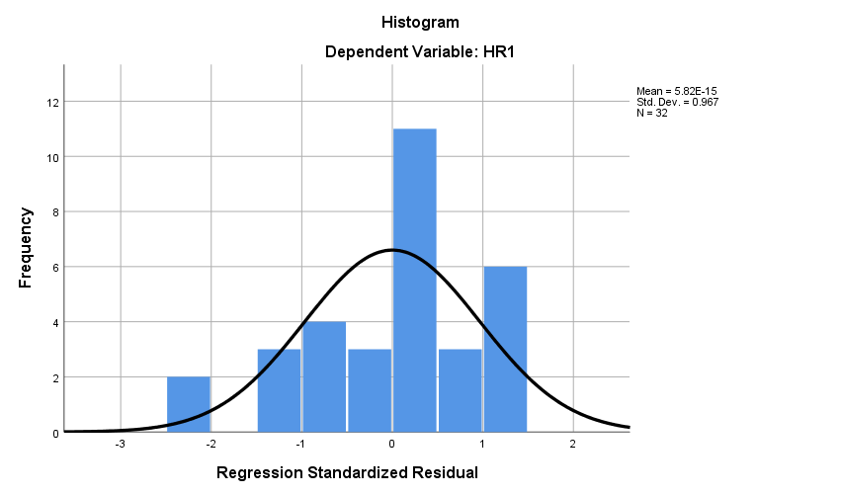

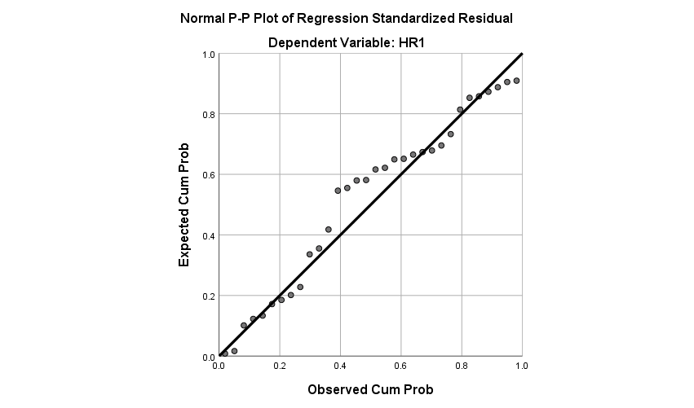

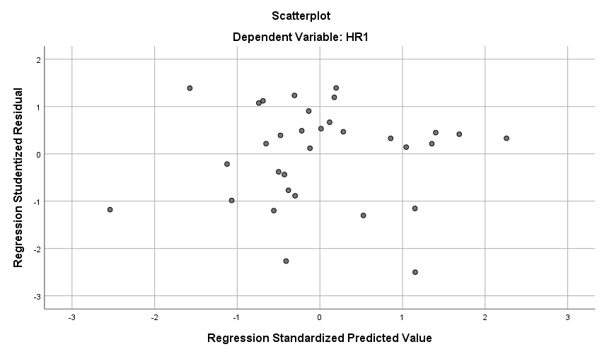

**NPar Tests**

|  |  |  |
| --- | --- | --- |
| **One-Sample Kolmogorov-Smirnov Test** | | |
|  | | Unstandardized Residual |
| N | | 32 |
| Normal Parametersa,b | Mean | .0000000 |
| Std. Deviation | .26406871 |
| Most Extreme Differences | Absolute | .173 |
| Positive | .084 |
| Negative | -.173 |
| Test Statistic | | .173 |
| Asymp. Sig. (2-tailed) | | .056c |
| a. Test distribution is Normal. | | |
| b. Calculated from data. | | |
| c. Lilliefors Significance Correction. | | |